PREMIUM Project Scope, Success criteria and Timeline

Step 1: Define the scope of your project.

Origin of your project: a problem or an ambition?
What needs to be solved? Is there a question behind the question?

What needs to be realized?
What has already been tried to solve the question?

Project Goals
Why is this important for the client right now?

What do they want to achieve with your deliverables?

Deliverables
What do you need to give to your client by the end of PREMIUM?
How to best present your results? What suits best within the type of organization of the client?
What IS or IS NOT part of the assignment? Define what’s inside your project, what you will be working on, and what is not part of your project.
What are the constraints the client puts on time, money, people or resources?

Stakeholders
Identity and differentiate stakeholders based on their interest and influence.

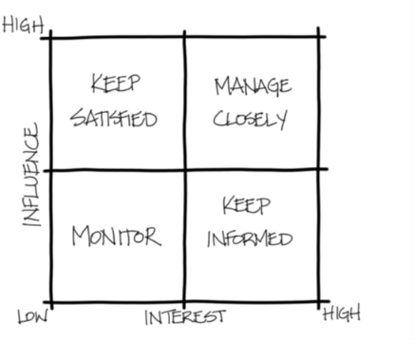

Decide within your team the role of the stakeholders.
(Are you going to research them, or actually involve them in the project? Also
discuss the communication to stakeholders during and/or at the end of the
project.)

Step 2: Indicate success criteria.

Success criteria
By the end of PREMIUM, what would make you happy as a team to have accomplished?
By the end of PREMIUM, what does your client see as a successful end result?
What are the quality standards of the client and the project team? How will you check the quality during the project?

Step 3: Indicate potential risks

Identify the project’s risks
What risks are involved in achieving the desired results?
Which are the most important and have the highest priority, and which the lowest?
What measures will be taken?

Step 4: Timeline

