|  |  |
| --- | --- |
| **Name:** |  |
| **Nationality:** |  |
| **PREMIUM Team:** |  |
| **Study Programme:** |  |
| **Career Ambitions  (if you already know):** |  |
| **Why PREMIUM?** |  |
| **What are your expectations in regard to the coaching sessions?** |  |

PREMIUM Personal Development Plan

## **How to use the PREMIUM PDP?**

Use this plan as a living document to guide your personal and professional development journey. Regularly update it with new insights and reflections from your coaching sessions and beyond. Remember, this is just the beginning of your continuous growth and improvement.

* **Part 1 A+B (MANDATORY):**   
  This part includes a set of suggestions of tools to help you define your development questions. Feel free to use whichever tool you feel suits you best, but use at least one tool. You may see it as a preparation for your coaching track;
* **Part 2 (OPTIONAL, TO BE INCLUDED IN CONSULTATION WITH YOUR COACH):**  
  This part includes some options of frameworks that provide a structured approach to self-assessment, goal setting, and action planning.
* **Part 3 (OPTIONAL, TO BE INCLUDED IN CONSULTATION WITH YOUR COACH):**  
  a log to track your progress over three coaching sessions. The focus will be on both "self" and "team" components. Feel free to define together with your coach how you want to document/track your progress over your coaching sessions.

## **The role of the Coach** As you embark on this personal development journey, it's essential to understand the role of your coach. The coach is here to guide, support, and challenge you as you work towards your personal and professional growth. The coach's responsibilities include:

* **Facilitator:** Helping you navigate through self-assessment tools and frameworks to gain deeper insights into your strengths, weaknesses, and aspirations.
* **Guide:** Assisting you in setting realistic and meaningful goals based on your reflections and assessments.
* **Supporter:** Providing encouragement and motivation, helping you stay focused and committed to your development plan.
* **Challenger:** Encouraging you to step out of your comfort zone, think critically, and explore new perspectives.

Psychological safety is a fundamental aspect of effective coaching. In your sessions, you should feel safe to express your thoughts, feelings, and concerns without fear of judgment or repercussions. This safe space allows for honest and open dialogue, fostering deeper self-awareness and personal growth.

* **Respect:** Your coach will treat you with respect and dignity, valuing your unique experiences and perspectives.
* **Non-judgmental:** Coaching sessions are a judgment-free zone where you can explore your challenges and successes openly.
* **Empathy:** Your coach will listen with empathy and understanding, ensuring that you feel heard and supported.

Confidentiality is paramount in personal coaching. Everything discussed in your one-on-one coaching sessions remains strictly confidential. This means that your personal information concerning your development, and the exact content of your discussions, will not be shared with others without your explicit consent. Please understand though, that your coach is in close contact with the mentor and PREMIUM Central Management at all times to ensure a safe environment for all PREMIUM students to thrive in. However, even then, only general observations or circumstances are shared.

# **Part 1A: Self-Assessment tools “where am I now?”**

A starting point for personal and professional development is self-assessment.   
Feel free to use whichever tool of the options below, you feel suits you best. **You may pick just one these tools, but you may also choose to do a couple of them (or even all),** pending how clear idea of your development question is already at the start of PREMIUM, and what you feel comfortable with. There are no right or wrong ways to go about this; this is your journey of development.   
In order for coaching to be most fruitful, we ask you to take this part seriously. Your coach can also give you some insights into the tools they feel might work best for their specific coaching style in relation to you.

***Disclaimer****Please note that the following assessments are tools for self-reflection and personal growth. They are designed to provide insights into various aspects of your personality, strengths, values, and motivations. These tests however, merely measure your traits and characteristics at a single point in time. They may not capture the full complexity of your personality or potential, nor should they be seen as definitive or exhaustive. If you find any of the results triggering or distressing, consider discussing them with your coach. It is important to remember that a certain test does not determine who we are; we get to decide for ourselves who we are. Personal development is a continuous journey, and these tools are just one part of that process. Some online tests collect and process your personal data in accordance with their respective privacy policies. Please review these policies before taking the assessments to understand how your data will be used.*

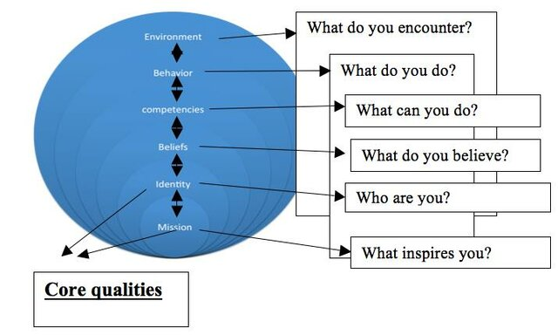

The onion model (Korthagen, 2004)

## **Personality Assessment:** Knowing your own personality, might help you to explain your behavior towards others and everyday things you do. It can also provide you with some insights that were not on your radar before.

* Myers-Briggs Type Indicator (MBTI): <https://www.16personalities.com/articles/how-to-take-a-personality-test>
* Big Five Personality Test: <https://www.123test.com/big-five-personality-theory/>
* DISC Personality Test: <https://www.123test.com/disc-personality-test/>

## **Strengths and Skills Identification:**

Knowing your strengths and understanding how each of them works together, you can identify the best path to success in any situation.

* High5 Test: <https://high5test.com/>
* Competence Test: <https://www.123test.com/competency-test/>   
  (you may also reflect on the PREMIUM workshop “Discover your Competences”)
* VIA Character Strengths Survey: <https://www.viacharacter.org/surveys>

## **Values and Motivations:** Your values reflect your beliefs and what is important to you. They are a shorthand way of describing your motivations. Your beliefs ground what you value – both drive your decision-making. If we remain aware of our values, we will increase our chances of making choices that are favorable to us. A personal list of values can be a compass for us, which in moments of doubt will remind us in which direction we want to go.

* Personal Values Assessment: <https://personalvalu.es/>
* Work Values test: <https://www.123test.com/work-values-test/>

**Team Roles and Dynamics:**   
Understand your preferred roles within a team setting, become more self-aware about the contribution you make to a team and where you could improve and grow.

* Team Roles Test: <https://www.123test.com/team-roles-test/>

## **Positive Health Assessment:**

The Dialogue tool from the institute for Positive Health is meant to help student reflect on their health in the broadest sense. A coach can help by asking open questions and by listening closely. By reflecting on their positive health, students might get ideas for personal development. Evaluate aspects such as physical health, mental health, social connections, and purpose in life. You can draw a spider web diagram to visualize balance in these areas.

* Download the spider web here to fill out and use as a dialogue during coaching: <https://www.iph.nl/en/participate/free-downloads/>
* <https://www.iph.nl/en/knowledge-base/filling-out-the-spider-web-yourself/>

## **Saboteur Test:**

Saboteurs are the voices in your head that generate negative emotions as you handle life’s everyday challenges. They represent the automatic patterns in your mind for how to think, feel, and respond. Your Saboteurs cause all of your stress, anxiety, self-doubt, frustration, restlessness, and unhappiness. They sabotage your performance, wellbeing, and relationships. The Saboteur Assessment is your first step to conquering your Saboteurs — identifying them and understand how they impact your behavior and decisions.

* Saboteur Test: <https://www.positiveintelligence.com/assessments/>

## **Wheel of Life Self- Assessment:**

Wheel of Life is a useful self-assessment tool that provides a so-called “helicopter view” on various dimensions of your life by identifying potential areas for development and goal setting. By completing it, you will be able to visualize how satisfied you are with different life aspects and see which of those might benefit from some improvement.   
  
Every category is represented by a slice of the pie and has a scale from 1 (very bad) to 10 (very good). By completing the wheel honestly and sincerely, you can find out which parts are going right and which parts may need more attention. The more extreme the number, the more improvement that category could use.

**Career & Development:** Is your career where you want it to be by now? Are you heading in the right direction? How focused are you on personal growth? Are you satisfied with your direction? Are you trying new experiences and seeking to learn?  
**Money & Wealth:** Are you earning enough income to satisfy your current needs? Are you financial setup for future growth in wealth?   
**Health & Fitness:** How physically healthy are you? Are you satisfied with your level of fitness? Are you satisfied with your diet?   
**Friends & Social:** Are your friends supportive of you? Are you engaging friends and socializing to your satisfaction levels?   
**Family:** Is your family supportive of you? Are you supportive of your family?   
**Love:** Do you feel loved? How often are you expressing love to others? Do you think of your abilities highly? Do you respect and love yourself? Do you appreciate yourself?  
**Fun:** Are you enjoying your life and making it fun? Are you satisfied with the level of activity that you do? Contribution: How would others rate your contribution to society or them as individuals?   
**Spiritual:** How connected are you to the inner and outer world? Are you satisfied with your relationship with your spiritual being?

* Score each slice of your Life Wheel, assigning the score that reflects how you feel yourself now within this area. How does your wheel look like? <https://wheeloflife.noomii.com/>
* Before going to your first meeting with the coach, think of the following questions when reflecting on your wheel of life:
* Why did you assign these scores in each category?
* How would you like to change the scores in the upcoming weeks, months?
* What are the priority area(s) for you to improve and be more satisfied with?

# **Part 1B: “Where do I want to be?”**

After having used one of more of the self-assessment tools, it is important that you reflect on your results.

Reflection questions that will help you to define development areas, goals or coaching questions to work on:

* What are your key strengths and weaknesses as identified by the assessments?
* What values and motivations drive you according to the values assessments?
* What patterns or themes do you notice across the different assessments?

Development areas, goals or coaching questions (to be filled out by student as preparation for the 1st coaching session):

|  |
| --- |
|  |

:

# **Part 2: Frameworks for Personal and Professional Development “How do I want to get there”**

Using a framework in your PDP equips you with practical tools to systematically approach your development. This structured approach not only enhances the effectiveness of the coaching sessions, but also fosters continuous personal and professional growth.  
  
We will leave it up to your own judgment, in close consideration with your coach, which framework to use. Your coach may also suggest an approach of their own.

Using a framework for personal and professional development can be helpful due to a number of reasons:

1. **Structured Approach:** Frameworks provide a structured approach to self-assessment, goal setting, and action planning. They help students organize their thoughts, identify specific areas of focus, and create actionable plans.
2. **Enhanced Clarity and Focus:** By using established frameworks, students can gain clearer insights into their strengths, weaknesses, opportunities, and threats. This clarity helps them prioritize their efforts and focus on what matters most for their personal and professional growth.
3. **Goal Setting and Achievement:** Frameworks like SMART Goals ensure that the goals set by students are Specific, Measurable, Achievable, Relevant, and Time-bound. This increases the likelihood of achieving these goals and provides a clear path for tracking progress.
4. **Facilitating Coaching Sessions:** Having a set of frameworks allows for more productive and focused coaching sessions. Both the student and the coach can use these tools to guide their discussions, make informed decisions, and measure progress over time.
5. **Balanced Life Assessment:** Tools like the Wheel of Life help students assess and balance different areas of their life, such as career, relationships, personal growth, and health. This holistic view ensures that they do not neglect any important aspect of their well-being.
6. **Empowerment and Self-Efficacy:** By providing students with these frameworks, they are empowered to take control of their development. They learn valuable skills in self-assessment, strategic planning, and problem solving that will benefit them throughout their careers and personal lives.
7. **Consistency and Repeatability:** Frameworks provide a consistent methodology that students can use repeatedly. As they encounter new challenges or set new goals, they can apply these tools to systematically work through their plans and track their growth.

## **Ofman's Core Quadrants Framework:**

Core Quadrants helps in identifying the interplay between strengths and weaknesses, and areas for personal growth. To gain more insights, it is advisable to complete the quadrant a couple of times.  
A full quadrant consists of 4 parts:

1. Identify your Core quality: what is a key strength or positive trait that defines you?
2. Determine your Pitfall: when overused or misapplied, how can you core quality become a weakness?
3. Find your Challenge: what quality do you need to develop to balance your core quality?
4. Recognize your Allergy: what behavior in others do you have a strong aversion to, often because it is an exaggerated form of your challenge?

While there is not a definitive list of these elements for every individual, here are some common examples that illustrate how the framework works:

|  |  |  |  |
| --- | --- | --- | --- |
| **Core quality** | **Pitfall** | **Challenge** | **Allergy** |
| Decisive | Dominating | Patience | Indecisiveness |
| Caring | Over-involvement | Detachment | Indifference |
| Analytical | Overly critical | Acceptance | Superficiality |
| Optimistic | Unrealistic | Realism | Pessimism |
| Flexible | Indecisive | Determination | Rigidity |
| Responsible | Overbearing | Trusting others | Irresponsibility |
| Assertive | Aggressive | Diplomacy | Passivity |
| Enthusiastic | Overzealous | Moderation | Apathy |
| Detail-Oriented | Perfectionistic | Seeing the big picture | Sloppiness |
| Independent | Isolated | Collaboration | Dependence |

The following sentences can help you to fill it out:

|  |  |
| --- | --- |
| **Core quality:**   * What I take for granted in myself.. * What others appreciate in me.. * What I expect or demand from others.. | **Pitfall:**   * What I am willing to overlook in others.. * What I tend to justify in myself.. * What others blame me for, label me.. |
| **Allergy:**   * What others tell me to relativize.. * What I would hate in myself.. * What I despise in others. | **Challenge:**   * What others wish me I had more of.. * What I miss in myself.. * What I admire in others. |

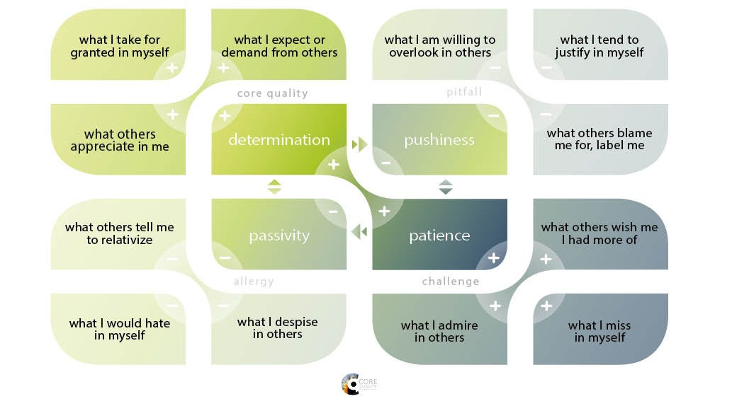Below an example of the Core Quadrants for the core quality “determination”.

## **SWOT Analysis Framework**

* **Purpose:** Helps students identify their Strengths, Weaknesses, Opportunities, and Threats (“Where am I”).
* **Benefit:** Provides a comprehensive overview of internal and external factors affecting their development.
* **How:** In bullet points, reflect on your strengths, weaknesses, opportunities and threats:
  + Internal (you): strengths 🡪 What do I do well, what am I good at?
  + Internal (you): weaknesses 🡪 What can I improve on?
  + External (context): opportunities 🡪 What can help my development?
  + External (context): threats 🡪 What can harm my development?

## **GROW Coaching Framework:**

Goals, Reality, Opportunity / Obstacles and Will / what next / Way forward – a structured way to approach personal development discussions.  
**Purpose:** Guides students through setting of Goals, understanding the current Reality, exploring Options, and determining the Will (action steps).  
**Benefit:** Provides a structured approach to problem solving and planning, facilitating deeper coaching conversations.

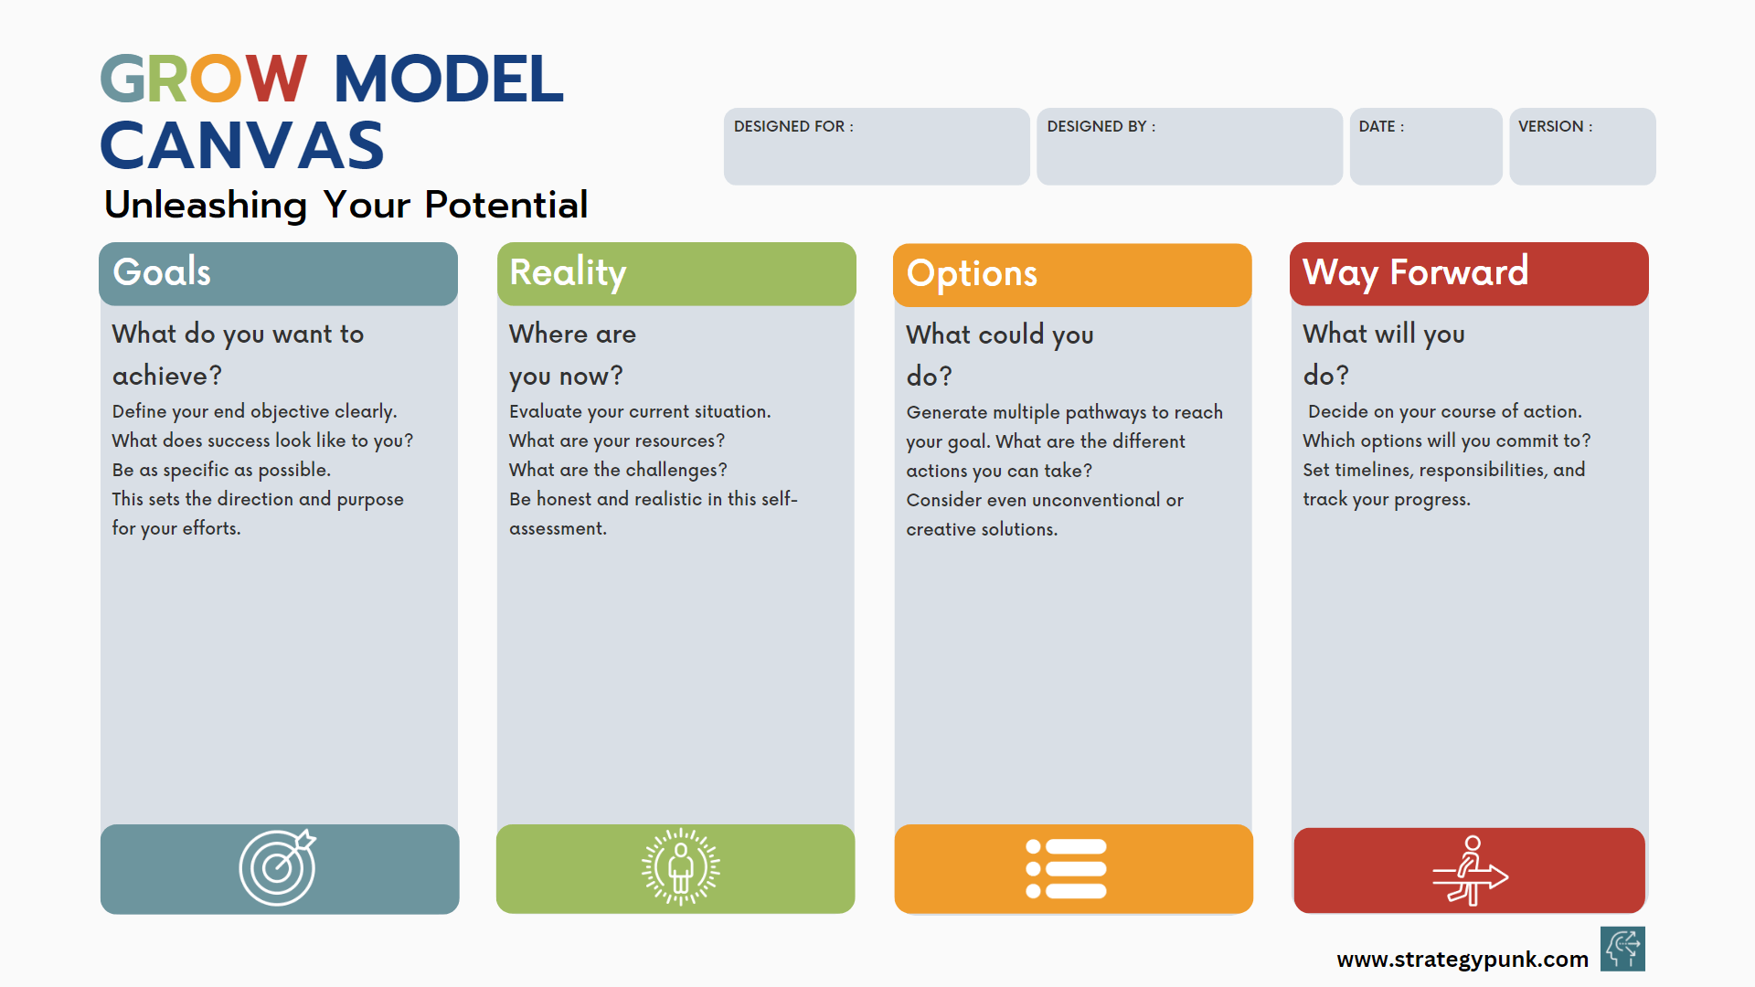

## **SMART Goals Framework:**

* **Purpose:** Ensures that goals are Specific, Measurable, Achievable, Relevant, and Time-bound.
* **Benefit:** Increases the likelihood of goal achievement by making goals clear and actionable.
* **How:** When thinking about the goals you will set yourself, you need to focus on ensuring they are aligned with the 5 elements of SMART.
  + **S**pecific: Avoid general ambiguous goals, get to the core of what you are trying to achieve. Focus on what it actually is that you want to develop.
  + **M**easurable: Making your goals measurable will help you to monitor your progress towards reaching your goal. This is related to making your goals specific, the more specific your goal is, the easier it is to measure. If you are struggling to measure your progress towards your goals, chances are you need to be more specific.
  + **A**ttainable: There really is no point in setting your goals unless they are achievable; some things are simply beyond your influence. It is OK to have goals that are challenging, but steer away from those that are extreme. Set goals that are achievable with the time and resources you have or can stretch to. Also, be aware that PREMIUM only facilitates 3 coaching sessions, and it is unlikely you will be able to have reached all your goals in these sessions.
  + **R**elevant: Are each one of your goals aligned to what you are working towards and will they help you to drive forward in achieving this? Relevant goals will help you to focus on activities that will support your development, saving you from wasting time on those that will not.
  + **T**ime bound: Giving yourself a deadline to work towards will help you to remain focused and eliminate other ‘more important’ tasks from taking over. Set yourself milestones along the way to keep you motivated and on track to reach your target.

# **Part 3: Coaching log “Putting a plan into action”**

With this optional log, both students and coach can document their sessions and findings. This template is can be used as a basis, since coaching is highly individual and often tailor-made. Feel free to add different discussion topics related to your individual coaching session.

## **Coaching Session 1: Initial Exploration and foundation for coaching**

|  |  |  |
| --- | --- | --- |
|  | **Student reflection:** | **Comments Coach:** |
| “Self-Component”: Self-assessment results and reflections |  |  |
| “Self-Component”:  Identification of initial personal and professional development areas, coaching questions. |  |  |
| “Team” component:  Reflection on team roles and dynamics, past team experiences, and personal contribution to teams. |  |  |

## **Coaching Session 2: Deep Dive and Action Planning**

|  |  |  |
| --- | --- | --- |
|  | **Student reflection:** | **Comments Coach:** |
| “Self-Component” Deep dive into specific development areas. Detailed analysis of personal goals and barriers. |  |  |
| “Self-Component” Strategies to counteract saboteurs. |  |  |
| “Team-Component”  Reflection on current team roles and individual performance in the PREMIUM team. Discuss strategies for effective teamwork and constructive team interactions. |  |  |

## **Coaching Session 3: Reflection and Future Planning**

|  |  |  |
| --- | --- | --- |
|  | **Student reflection:** | **Comments Coach:** |
| “Self-Component” Reflection on personal growth and remaining challenges. Adjustment of action plans based on experiences and feedback. |  |  |
| “Self-Component” Planning for continued development post-coaching. |  |  |
| “Team-Component”  Evaluation of team interactions and future team-oriented goals. |  |  |