Honours+ Team Charter
Research on team performance shows that high-quality team charters (written plans for how the team will manage its activities) are positively related to team performance.
Drafting a team charter increases team members’ knowledge of the strengths and weaknesses within the team, helps to create shared expectations, and facilitates the establishment of effective group practices for dealing with high and poor performance.
A team charter is a strategic framework that helps team members to kick off projects and align on common vision. It is made to smoothly start collective projects, let people learn about each other and accumulate enough momentum to get going.

The Honours+ team charter has two parts

Part 1: The individual charter
In the individual part you answer a number of questions about yourself and your expectations with respect to the performance of your H+ team. Part 1 is to be filled out by each team member individually prior to the first team meeting.

Part 2: The team charter
In the team part, you discuss together your team roles, expectations and processes. You fill out the team charter as a group during your first team meeting, and submit it to your H+ Supervisor directly after the meeting.
- Note: we advise you to refer back to your initially made agreements throughout the course of your Challenge, to see if you are still as a group adhering to these agreements and values.

Suggestion for setup of team session to fill out the team component
- Duration: 30-45 minutes
- Materials:
  - Download a Team Canvas via the Honours+ documents page, and project it on a (online) whiteboard or print it on a big enough piece of paper.
  - Blocks of sticky notes, one for each participant, different colours;
  - Sharpies or markers to write on stickies (use thick enough pens so everyone can see the writing);
  - A device with a timer function.

- Go through each step with the team, making sure you ask the questions for each segment. Encourage people to write their answers on stickies and talk about them with the team. Make sure to agree on all fields. Your individual answers will provide input for these answers.
- Use timer for each step (max 10 minutes per step) to apply some time pressure so the team really focuses on getting to the point in each section discussion. If some conversations take rather long time or seem to touch upon bigger issues, consider parking those questions, and plan a separate meeting to address them specifically.
- Once you have agreed on every component, fill out the team component of the charter.
- Wrap up (5 minutes): talk about one single most important insight that each team member gained during this activity. Afterwards you will need to reflect on this in your Personal Development Plan (PDP) as well.
- IMPORTANT: there are no good or wrong answers here. Everyone’s opinion is equally valuable and justified, and necessary to lay the foundation of good team functioning. Try to be supportive, have an open mind, but also do not be afraid to ask (critical) questions.

Part 1: Individual preparation
Please fill out this part of the team charter individually, before meeting with your team for the first time. During this first team meeting, you will share your answers with the group, and they form the basis of the team component.

Your individual profile

People & Roles: Please provide some information on your personal background (e.g. where you grew up, what courses you have followed, hobbies, personality traits).
- People & Roles: What are your preferred working styles, particularly in relation to teamwork? Please refer to the Belbin team roles.

Goals: What do you consider the criteria/elements of a perfect team?
- Personal Goals: What aspect of your personal agenda would you like to open up? (examples: availability conflict during certain period, motive for joining Honours etc)
- Purpose: Why did you prefer this particular Challenge topic? What expertise and knowledge can you see that might be of use here?

Strengths & Assets: What strengths do you have that can contribute to the functioning of your Honours+ group?

Needs & Expectations: What do you need from the team to improve/optimise your individual contribution?

Weaknesses & Development areas: What aspect of personal development would you like to work on during Honours+?

Weaknesses & Development areas: What do you feel your team members or Supervisor should know about you?

Your expectations regarding the team
- Goals: What would you ideally like to achieve as a team in this project?
- Values: What are values that you would like to be at the core of your team? (examples: honesty, relationships, teamwork, profitability, and passion)
- Purpose: What do you feel is the purpose and relevance of your team in this project and potential research question?
- Needs & Expectations: What would make this team successful? How is that measured?
- Needs & Expectations: What would you expect from your team member’s work ethic? For example, showing up on time, indicating when members will miss a meeting, equal contribution, meeting deadlines.
- Rules & Action points: What rules would you introduce as standard in your team with respect to accountability? (examples: how do we address free-riding, what is considered free-riding, how do we hold each other accountable)
- Rules & Action Points: How do you prefer to make decisions in your team, even when working under stress?
- Rules & Action Points: How do you prefer to communicate in a team and ensure the Supervisor and team members are updated?
- Weaknesses & Developments areas: What obstacles for your team do you believe your team might likely come to face?

Part 2: Team roles, expectations and processes
In Part 1 each student answered the questions individually. During the team meeting, the idea is to come up with collective answers/decisions for all questions/themes.

Team performance
- People & Roles: Team name
- People & Roles: Roles we have in the team
- Purpose: Why are we doing what we are doing in the first place? What direction would you like your research to go into?
- Goals: What do we want to achieve as a group?
- Goals: What are our key goals that are feasible, measurable and time-bounded?
- Personal Goals: What are our individual personal goals?
- Personal Goals: Are there personal agendas that we want to open up?
- Values: What do we stand for, what are our guiding principles?
- Values: What are our common values that we want to be at the core of our team?
- Needs & Expectations: What does each of us needs to be successful in this team?
- Needs & Expectations: What are our personal needs towards the team to be at our best?
- Needs & Expectations: What work ethic do we expect from each other?
- Needs & Expectations: How do we ensure our team is a safe space for all team members? How do we build trust? How do we go about holding each other accountable without compromising the safe space?

- Rules & Action Points: What are the exact rules we want to introduce after doing this session?
- Rules & Action Points: How do we communicate and keep everyone up to date?
- Rules & Action Points: How do we make decisions?
- Rules & Action Points: How do we execute and evaluate what we do? Think of celebrating achievements, overcoming setbacks. What is considered a success, a setback etc?
- Strengths & Assets: What are the skills we have in our team that will help us achieve our goals?
- Strengths & Assets: What are interpersonal/soft skills we have?
- Strengths & Assets: What are we good at, individually and as a team?
- Weaknesses & Development Areas: What are the weaknesses we have?
- Weaknesses & Development Areas: What should our team members, client, coach or mentor know about us?
- Weaknesses & Development Areas: What are some obstacles we see ahead of us that we are likely to face, and how do we propose to overcome them?

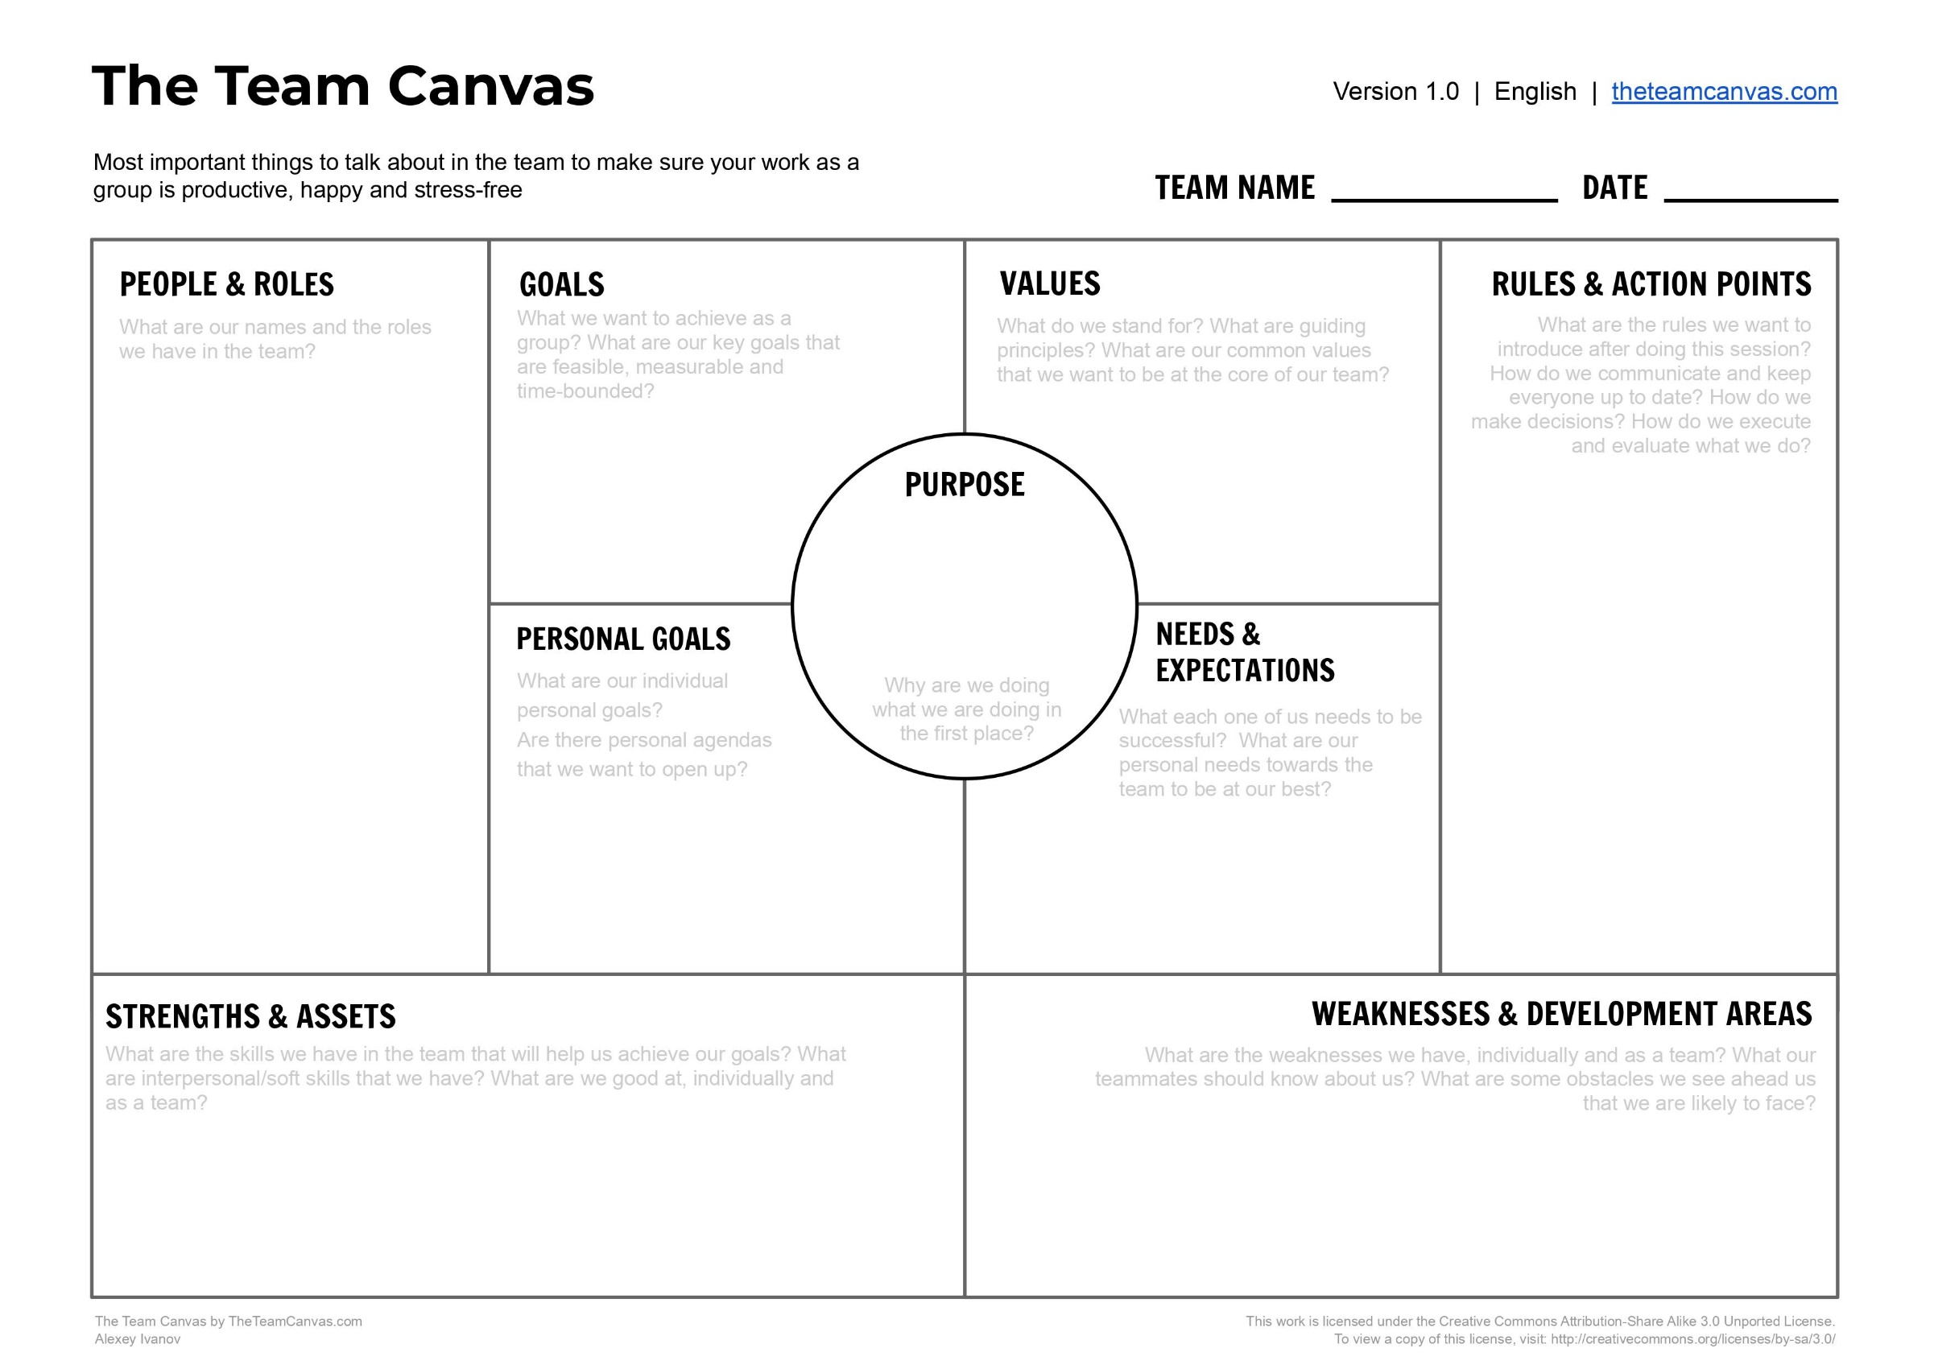

Mathieu, J. E., & Rapp, T. L. (2009). Laying the foundation for successful team performance trajectories: The roles of team charters and performance strategies. Journal of Applied Psychology, 94(1), 90-103. doi:10.1037/a0013257
https://theteamcanvas.com/learn/

