Self-assessment form on reflective practices

Please, fill out this form individually and send it to your project mentor before the midterm and closing evaluations meeting. Do not forget to reflect on your process of reflection in the PDP.
Note: this reflection form is focused on your work on the content of the project and the process of completing the project.
You can also voluntarily use the reflection form as a basis during Team Dynamics meeting with your coach, or your personal competence coaching aspect of the programme.
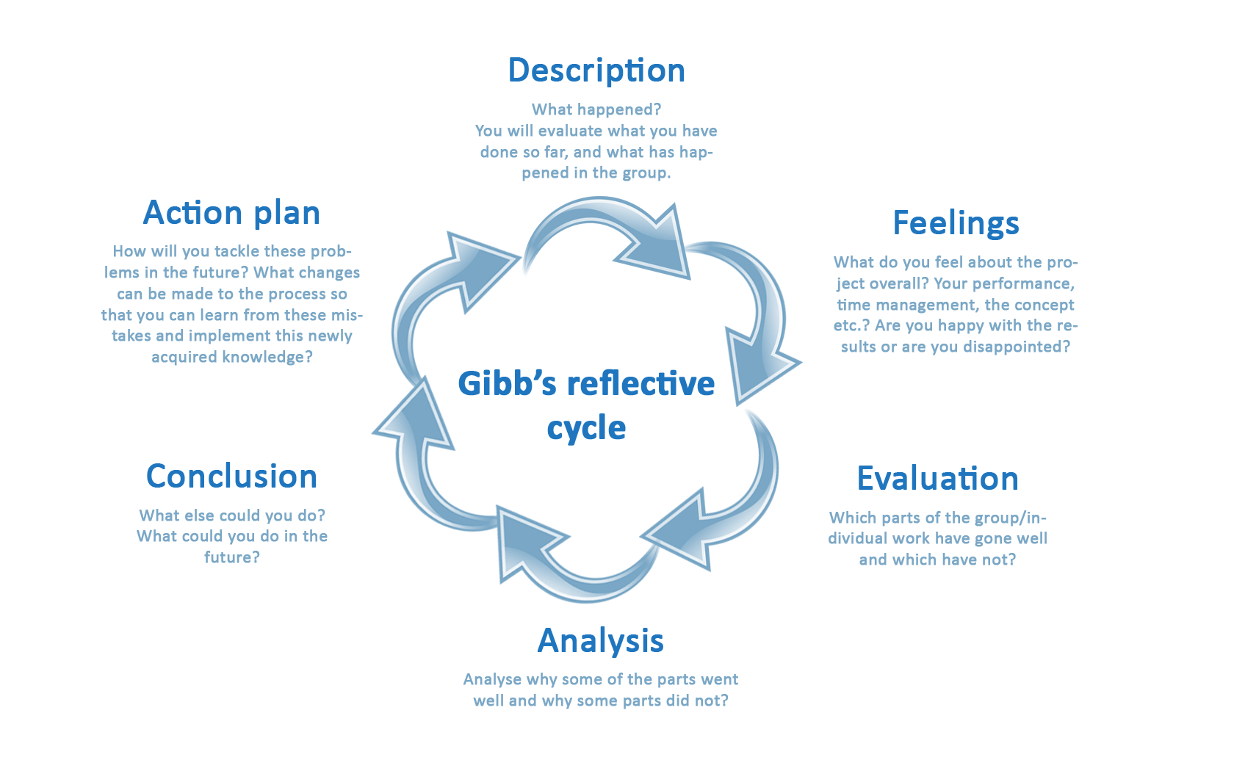
This form is based on Gibb’s reflective cycle to help you explore and analyse the practices you perform:

 | Individual part | Team part
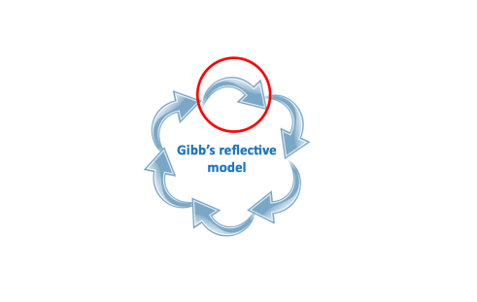  Description | Midterm Reflective Practitioner Meeting: What have you done so far? What happened with your project within the first half of the programme?  Closing Meeting: What has your added value been to the project? What happened with your project during the second half of the programme? What happened with your action plan as defined in the previous meeting?
Feelings  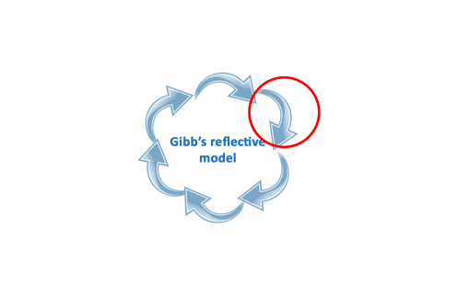 | How do you feel about the project overall? About your performance, contribution to the project etc.? | How do you feel about the team performance and the development of the project from the team’s perspective?
Evaluation  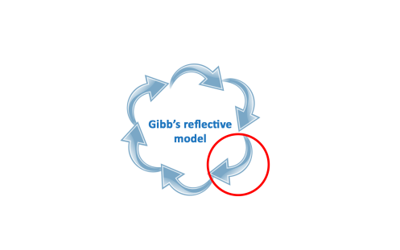 | Which parts of the individual work have gone well and which have not? If everything went well, evaluate what factors contributed to this success. | Which parts of the group work have gone well and which have not? If everything went well, evaluate what factors contributed to this success.
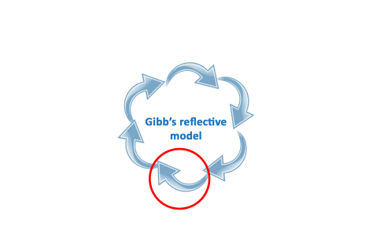  Analysis | What analysis have you done based on your evaluation? Which parts went well, which parts didn’t and why? | What analysis have you done based on your evaluation? Which parts went well, which parts didn’t and why?
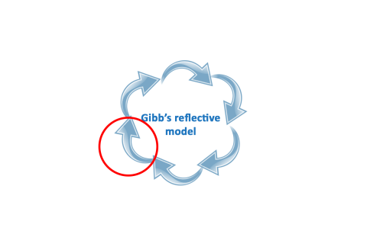  Conclusion | What could you have done in order to prevent certain matters?  What qualities do you appreciate in your team members and what can you learn from them? | What could have been done by your team in order to prevent certain matters?  What qualities do you appreciate in your team members and what can you learn from them post-PREMIUM?
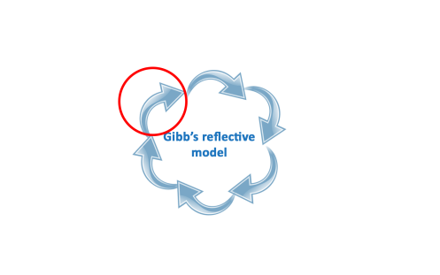  Action plan | Midterm Meeting: What are you going to do next? How will you tackle these problems in the future?  How will you take into account the feedback you received during your Midterm presentation?  Closing Meeting: How will you tackle these problems in the future? | Midterm Meeting: What is your team going to do next? How will you tackle these problems in the future with your team?  How will you take into account the feedback you received during your Midterm presentation?  Closing Meeting: How will you tackle these problems in the future within a team setting?

