Self-assessment form on reflective practices

Please, fill out this form individually and send it to your Supervisor before the Midterm Feedback Session.
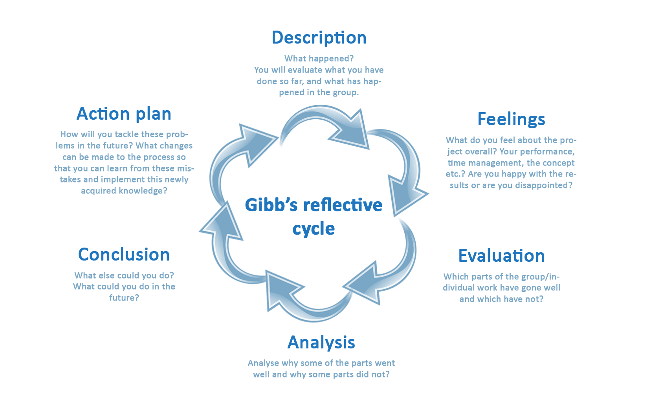
This form is based on Gibb’s reflective cycle to help you explore and analyse the practices you perform:

 | Individual part | Team part
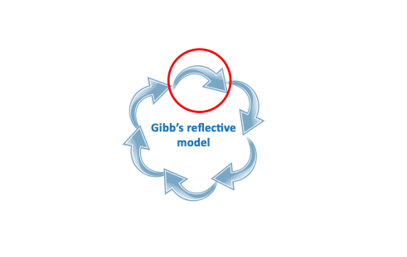  Description | What have you done so far? What happened with your Challenge within the first half of the programme?
Feelings  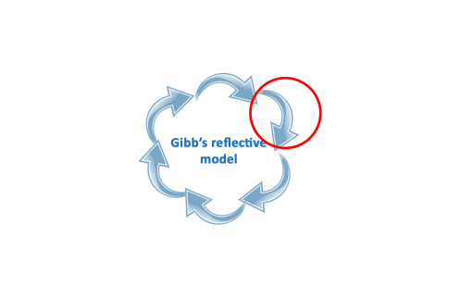 | How do you feel about the Challenge overall? About your performance, contribution to the research etc.? | How do you feel about the team performance and the development of the Challenge from the team’s perspective?
Evaluation  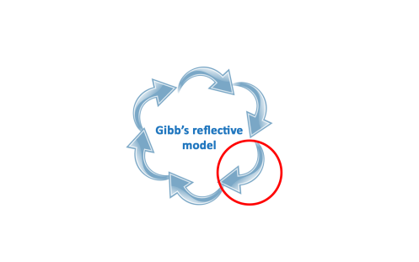 | Which parts of the individual work have gone well and which have not? | Which parts of the group work have gone well and which have not?
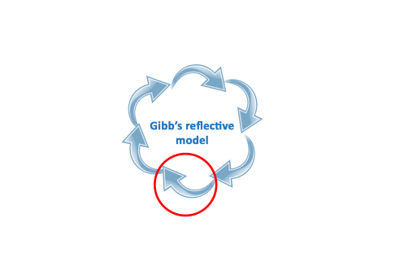  Analysis | What analysis have you done based on your evaluation? Which parts went well, which parts didn’t and why? | What analysis have you done based on your evaluation? Which parts went well, which parts didn’t and why?
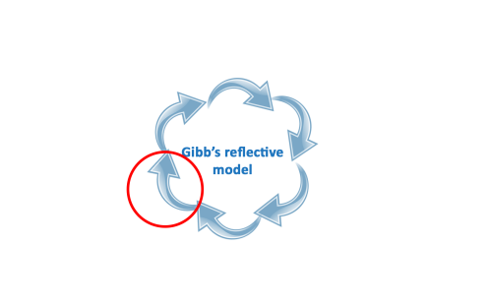  Conclusion | What could you have done in order to prevent certain matters? | What could have been done by your team in order to prevent certain matters?
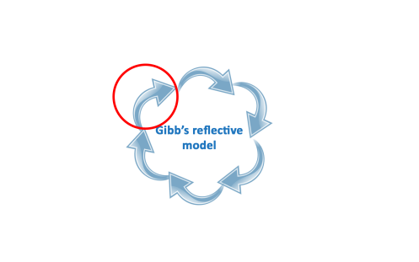  Action plan | What are you going to do next? How will you tackle these problems in the future? | What is your team going to do next? How will you tackle these problems in the future with your team?

