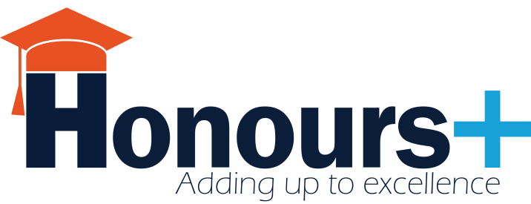

Dear prospective Honours+ Supervisor,
Thank you for choosing to propose your academic issue or question to Honours+. We sincerely hope to work together in this upcoming year of Honours+ and look forward to reading your proposal.
Please note that the deadline for assignment proposals is October 16th.
Depending on the total number of selected students and their personal project preferences, we will inform you around October 23rd about your actual Honours+ student team, which you then will meet during the Honours+ kick-off on October 31st.
If you have any questions, please do not hesitate to contact the Honours+ Central Management Team at honoursplus@maastrichtuniversity.nl.
Warm regards,
The Honours+ Central Management Team

Please provide us with your information.
Your name
The faculty you work at
The department you work in
Your email address
Your phone number(s)
Your office location

The spirit of a true Honours+ assignment
A true Honours+ assignment must be adequately challenging, push students outside of their comfort zone, call for an innovative solution, and allow, or better yet facilitate, a combination of disciplinary perspectives. The assignment should be linked to UM’s three main research themes (Europe and a Globalizing World, Learning and Innovation, Quality of Life). The assignment should be large enough to require an investment of approximately 125 hours per student (max. 8 students) and should be able to result in recommendations to UM’s Executive Board.
Please answer the following questions regarding your proposed Honours+ assignment.
Please provide a short description of you and your field of work (±100 words):

What academic issue or problem would you like the Honours+ students to address? (±100 words)

Please indicate the research theme of UM’s strategic programme, your proposed assignment should be grouped under. (please choose only one) | - Europe & a Globalizing World  - Quality of Life  - Learning & Innovation

Please answer the following questions to inform us of your student team preferences.
Please indicate the most essential major disciplines that you believe would provide the most valuable insight to your project (please select multiple): | - Psychology  - Economics  - Business  - Law  - Cultural sciences  - Social sciences  - Data Science and Knowledge engineering  - Other, …
Is there any further information about your proposed assignment you wish to inform us about? Or do you have any further questions? | - No  - Yes , …

Availability
Please indicate below your availability:
- I’m physically present for team meetings for most of the time during November-Mid May, and am willing to occasionally meet during the evenings if team scheduling requires so.  - Supervisor introductory meeting. Date: October 31st, 17:00-18:00.  - Honours+ kick-off: Festive opening of Honours+ where you will meet your student team for the first time. Date: October 31st, 18:00-21:00.  - Closing Event: Festive closing of Honours+. Date: May 25th, 18:00-21:00 | YES/NO  YES/NO  YES/NO  YES/NO

Please write a short (max. 200 words), promotional text for our website to inform students about your assignment. Please include a short description of the problem you wish the student team to address, and the opportunities you are able to offer the students.

Thank you for proposing an Honours+ assignment. Your contribution is highly appreciated.
We will contact you soon regarding the further process.

DKE. In this bachelor's programme, student study logic, intelligent search, and machine learning. They collect and organise relevant information using mathematics and smart computer techniques. They also use models and computers for data analysis. The ultimate objective is to develop user-friendly software and intelligent systems for -among others- healthcare, IT, robotics and commercial gaming. Upon graduation, they can look forward to a promising career, as data scientists and knowledge engineers are in high demand. The DKE Honours programme consists of two different tracks: a research oriented track and a practice oriented track (also known as KE@Work) each in combination with a common part: Honours+ - KE@Work: Students are placed at a business through a careful selection and matching process. During the full second and third year of the bachelor program, they spend 50 % of the time in class and 50% at the business, where they work on solving academic challenges and complex business problems. - Research track: In the research track, students get the opportunity to work on a state-of-the-art research project. Work will be organized in a similar way as in professional research institutes where students work together as individual experts on a team project. Each student specializes in a task, will get assigned a team role and receives a self-contained research project. Together they will be working towards a common demonstration where individual research projects integrate towards a journal publication.

